# **clPOSTING OF PHARMACY CHECKS**

**Follow the steps below for posting Pharmacy checks in eCW:**

1. In eCW click on Billing then Payments.
2. Click on Payment Batch in the upper right-hand corner of the screen.
3. Click on Start Payment Batch.
4. The “Create Payment Batch” screen will come up. The date will default to today’s date.
5. Check the “Default Batch” box
6. In the “Name” field, enter today’s date (MM/DD/YYYY) and your initials.
7. Enter the amount of check (or total of all checks if posting more than one) otherwise known as the “batch amt”, and then click done.
8. Then go to the box with that shows (**…**) next to Batch # in the center of the top of the page.
9. Your payment batch will then appear with a check mark, then click OK. Your batch # will then populate and then click “Lookup” in the top right corner to go to your payment screen.
10. Add your batch # to the ERA Recon spreadsheet.
11. Click on Add Insurance Payment near the top right of the screen or click F4. Type in insurance name and then click ok. (for RX, type the prefix QS1- then insurance name)
12. On the Payments (Insurance Payment) screen, change the type to “check”, enter the Check #, enter the check amount, click the boxes for “Check Date “and “EOB Date), then enter the check date in both of those fields. Those dates are the same.
13. Click Time Stamp (clock icon). Then type the following order: insurance, SSP or CHP, Check #, Check Date, Check amt, and PMT ID (you will have to click on “Payment Advisory” to get your PMT ID – it will be in the top left corner).
14. Add your Payment ID in the ERA Recon spreadsheet
15. Click Payment Advisory
16. Enter the RX number and hit enter or click OK. (RX number starting with 0 for Campus Health Pharmacy; 1 for Student Stores Pharmacy)
17. Please see instructions for adding fees and interest.
18. The claim information will come up. Enter the amount insurance paid.
19. Select the claim assignment and claim status and click post payment. There are various claim status entries that may be applicable to specific claims.

# Posting Prime and TPS Checks

We receive most of the Explanation of Benefit statements for prescription payments for our pharmacy vendors from the Pharmacy First website: [http://www.pharmacyfirst.com/#](http://www.pharmacyfirst.com/). After we receive notification from the Cashier’s office that we have a check from TPS, we download the EOB to our S-drive for easy reference and posting. To do this login using one of the following userid/passwords below.

Step 1. [http://www.pharmacyfirst.com/#](http://www.pharmacyfirst.com/)

Step 2. Click on Member Login

Healthy Heels Shoppe: **User ID 3427792**

(Campus Health Pharmacy) **Password ZY4HSUI@**

Student Stores: **User ID 3465653**

**Password 2PQ0KLL$**

Step 3. Click on **MONEY MANAGEMENT** then click the **VIEW DETAILS** hyperlink in the PAYMENT SUMMARY box:

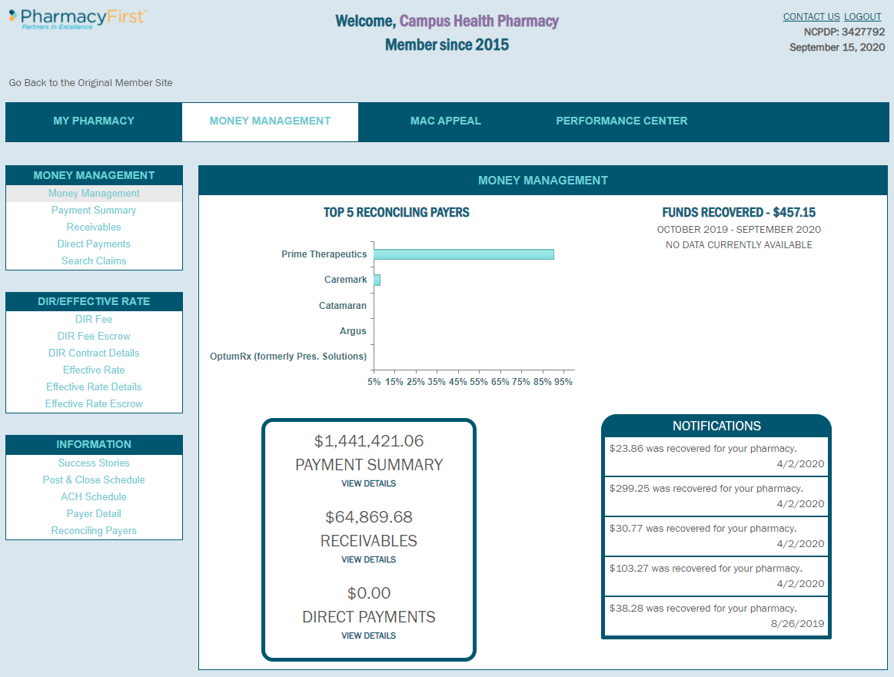

This will bring you to this month’s calendar. Click on the date/blue dollar hyperlink of the EOB that you are looking to post.

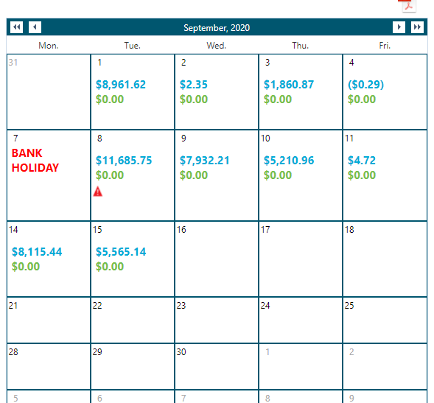

In this example, we will use September 15, 2020 and click on the $5,565.14 dollar amount.

This screen will display:

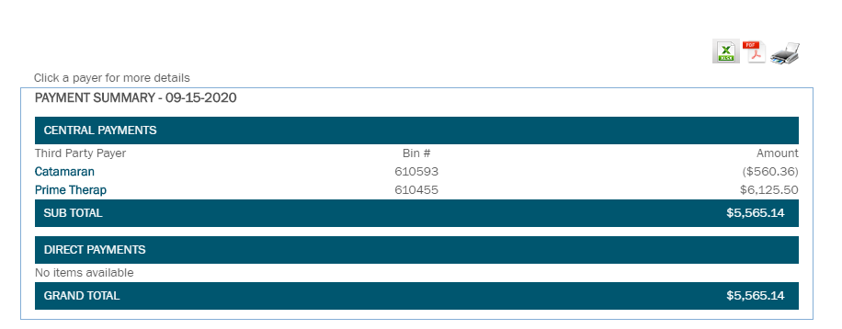

There are two separate Pharmacy vendors in this total check. Catamaran and Prime.

Click on the Catamaran hyperlink. This will pull up the payment summary for Catamaran which lists each prescription number and the amount paid.

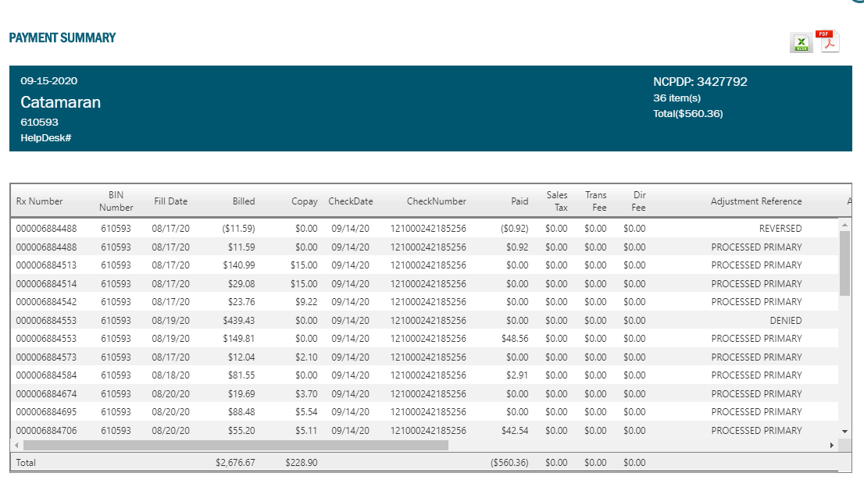

Save this file to the Patient Accounts S-drive by

* clicking on the excel icon in the upper right corner
* Open the excel sheet
* Enable Editing
* FILE/SAVE AS
* Browse to the appropriate location to store the EOB.

(S:) CHS > Patient Accounts > CHECKS (vendor name) > (Pharmacy CHP/SSP) (year) > save the EOB using this format: vendor name / check # / date / dollar amount / PMT ID

In our example:

(S:) CHS > Patient Accounts > Checks Catamaran > Catamaran CHP 2020 >

121000242185256 09-15-2020 ($560.36) PMT xxxxxx

(You will replace the xxxxxx with the actual PMT number in a subsequent step.)

Your file will resemble:

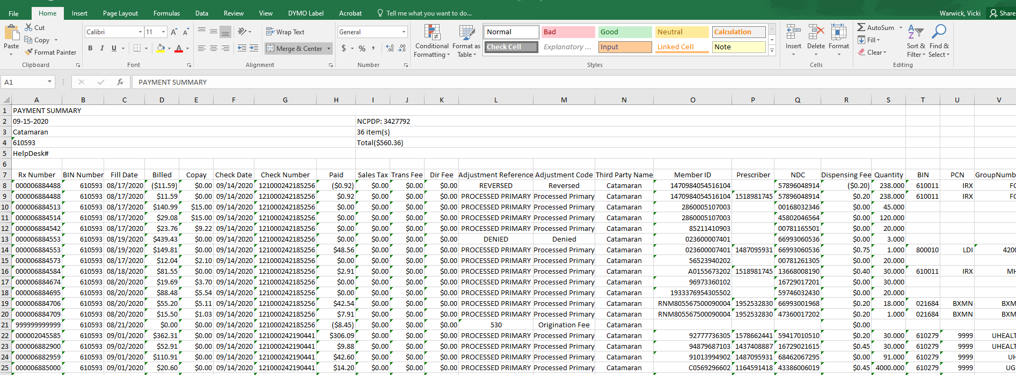

To create pharmacy prescription numbers to match the numbers in eCW:

* Highlight just the data, not the heading
* Click on the Find & Select search tool
* Replace
* If CHP
  + Find what: 00000
  + Replace with: ‘0
* If SSP
  + Find what: 00000
  + Replace with: 1
* Replace All

To put the data in date order:

* Click on the DATA tab
* Sort data by Fill Date
* OK
* Click the circle Sort anything that looks like a number, as a number
* OK

Now we’re going to sort out transactions that we do NOT need to enter:

* Click the Filter
* In the Paid column dropdown, uncheck the select all box
* Select $0.00
* Select $0.20 (Prime)
* Select -$0.20 (Prime)
* OK
* Highlight the resulting rows and pick a color
* Go back to the Paid column dropdown and check the select all box
* OK

Repeat this process for all other EOB’s listed on that check. Once all of the EOB’s have been loaded to the S-Drive, log in to eCW.

Click on Payments in the Billing tab:

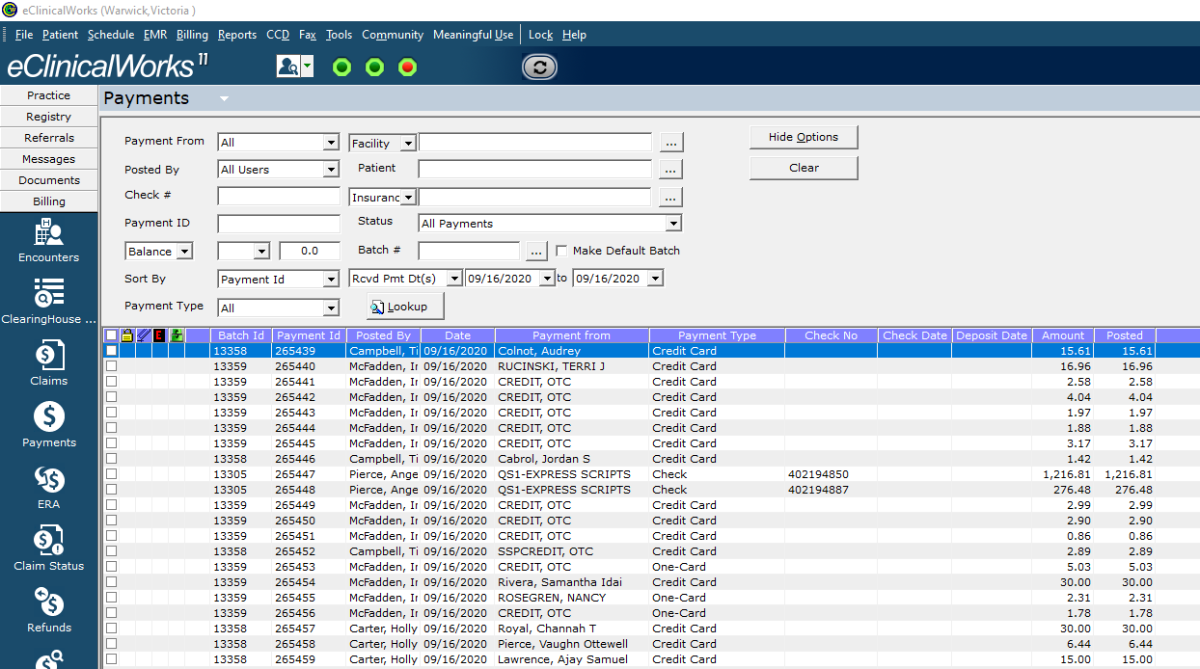

On the bottom left corner of this screen, click on the Payment Batch dropdown.

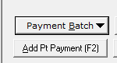

Select Start Payment Batch. The following screen will display.

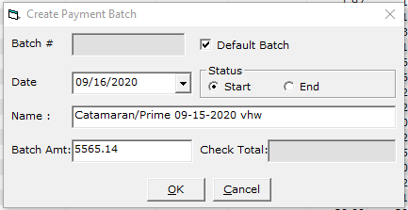

* Check the Default Batch box
* Name the batch with the EOB’s that are included on the check, date of the check and your initials.
* Fill in the total batch amount
* Click OK

Now you need to find your batch in order to enter the payments:

* Click on the three dots

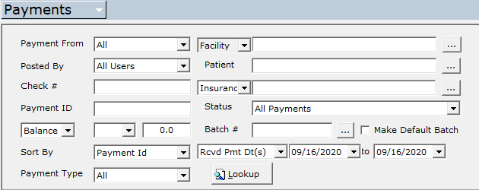

You will need to check the Created by All box to find the batch you just created:

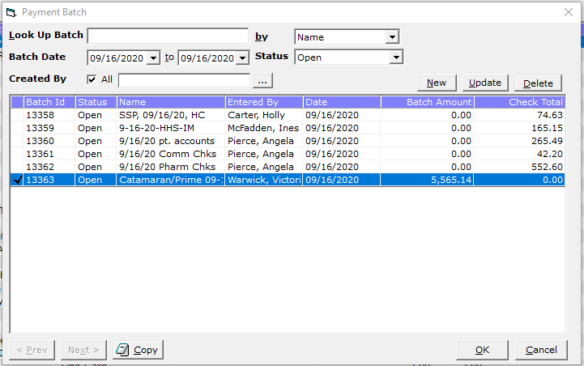

Click OK

Your batch number will automatically populate in the payments screen.

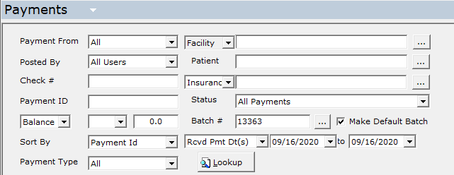

* Make note of the batch number
* Check the Make Default Batch box
* Click Lookup

You should be presented with a blank payment screen. On the bottom left corner click Add Ins Payment

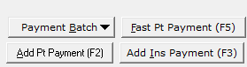

Search for the Insurance vendor with QS1- as your prefix. In this example, we are looking for Catamaran

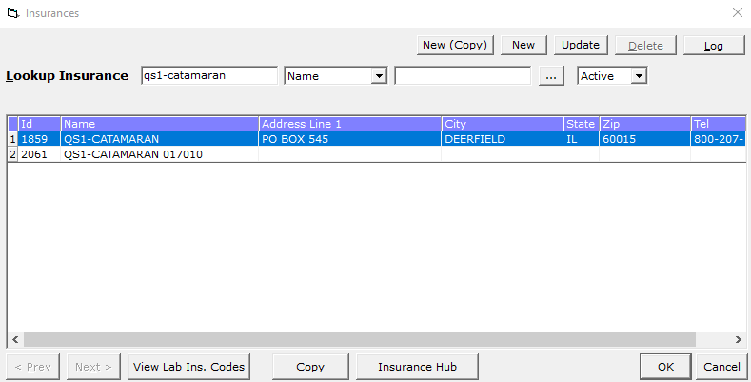

Click OK

Fill in the next screen

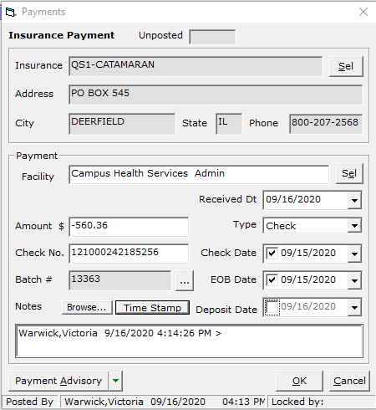

* Check Amount
* Check No.
* Type dropdown – check
* Check Date/EOB Date are the same
* Time Stamp
* Click Payment Advisory

You are presented with a blank Payment Advisory screen:

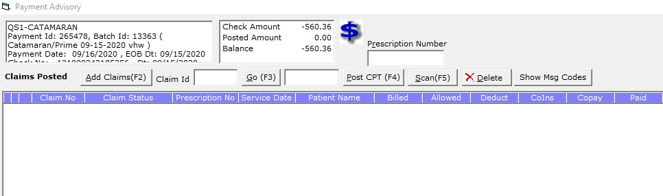

* Rename your EOB file with this number:

(S:) CHS > Patient Accounts > Checks Catamaran > Catamaran CHP 2020 >

121000242185256 09-15-2020 ($560.36) PMT 265478

Now you can begin entering your payments from the excel sheet that you downloaded earlier. Copy the prescription number

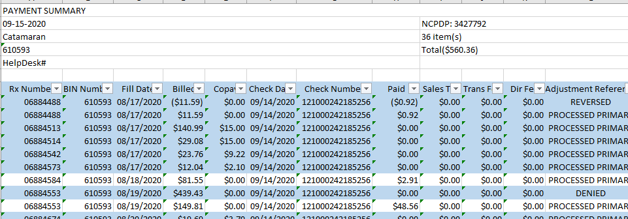

And paste it into the Prescription Number box on the eCW Payment Advisory and click GO (F3)

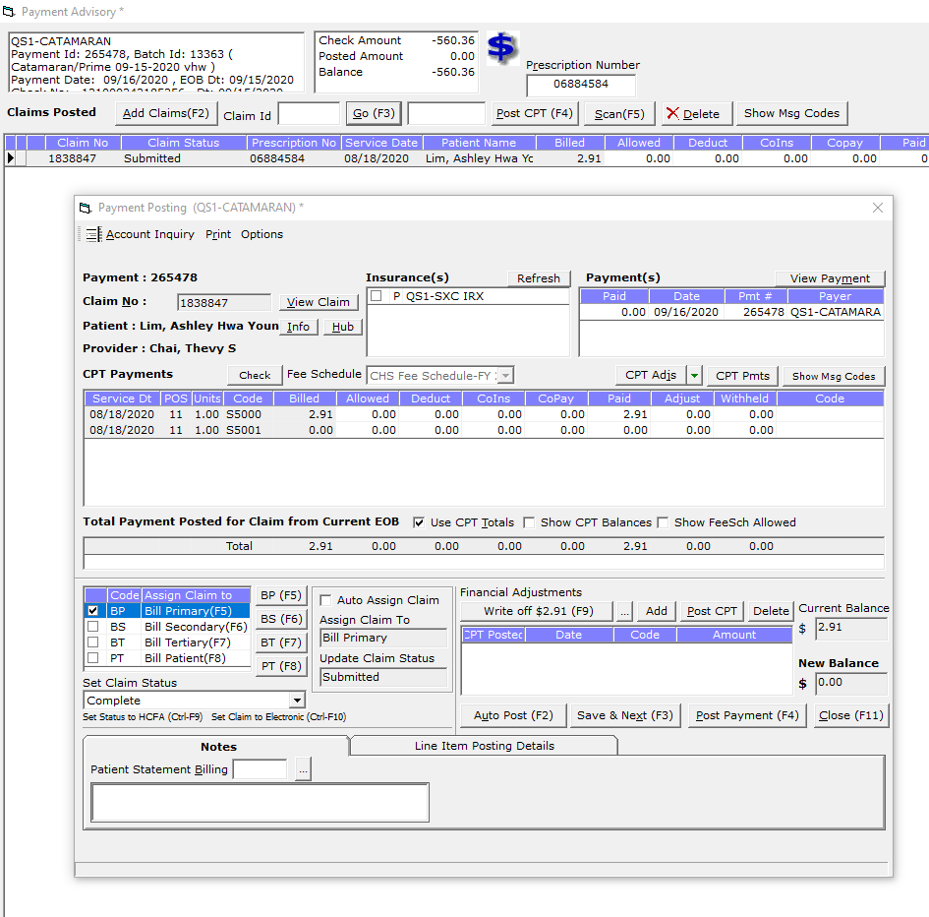

The claim will display. Enter the paid amount in the Paid column on the S5000 row. This will do one of two things:

1. Create a $0.00 New Balance – then COMPLETE the claim and Post Payment
2. Or cause a copay balance:

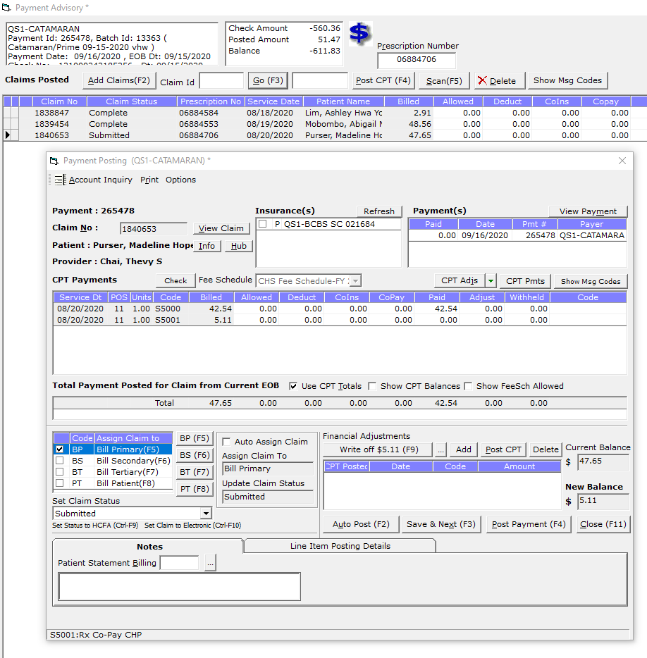

In these cases, click View Claim to see if the claim status should be set to

* **CAA for Review** for athletics to pay
* **Bursar** for the student to pay through their student account
* **Patient** for the PostDoc/Private Patient to pay through invoice

Click Post Payment

Sometimes when you enter a prescription number, a list of claims will come up. **Please be sure to enter the payment on the correct claim date!**

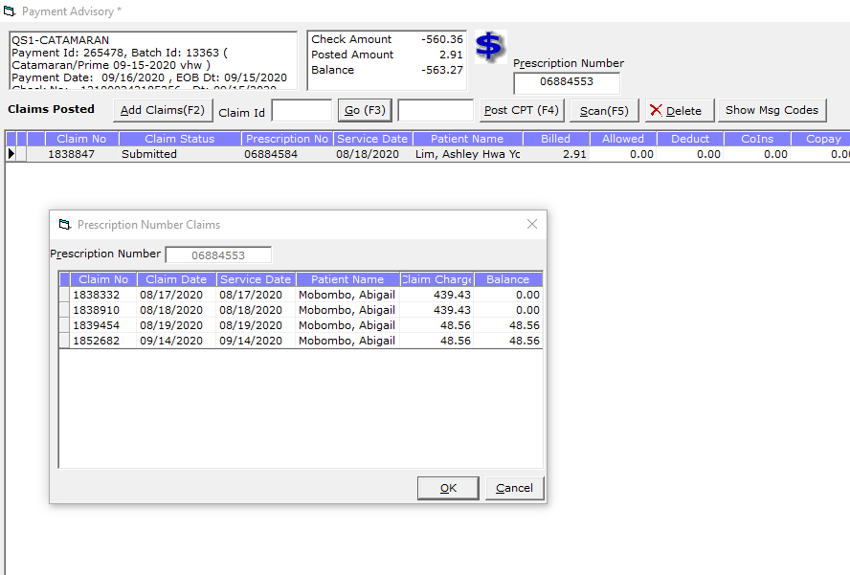

Continue to enter the payments. You can highlight each row as you go to keep your place on the sheet.

Hints and Tips:

Enter the payment amount shown on the claim. If it is 20 cents over, enter that amount. The 20 cents will be reversed at the end of the check in the form of an interest claim.

There may be times when you will have a claim number that is shown as 999999999999. These are interest, fees or forward balance payments. To process these lines you will need to create a claim.

* Click ok to save your payment advisory screen.
* Click on Claims on the left ribbon:

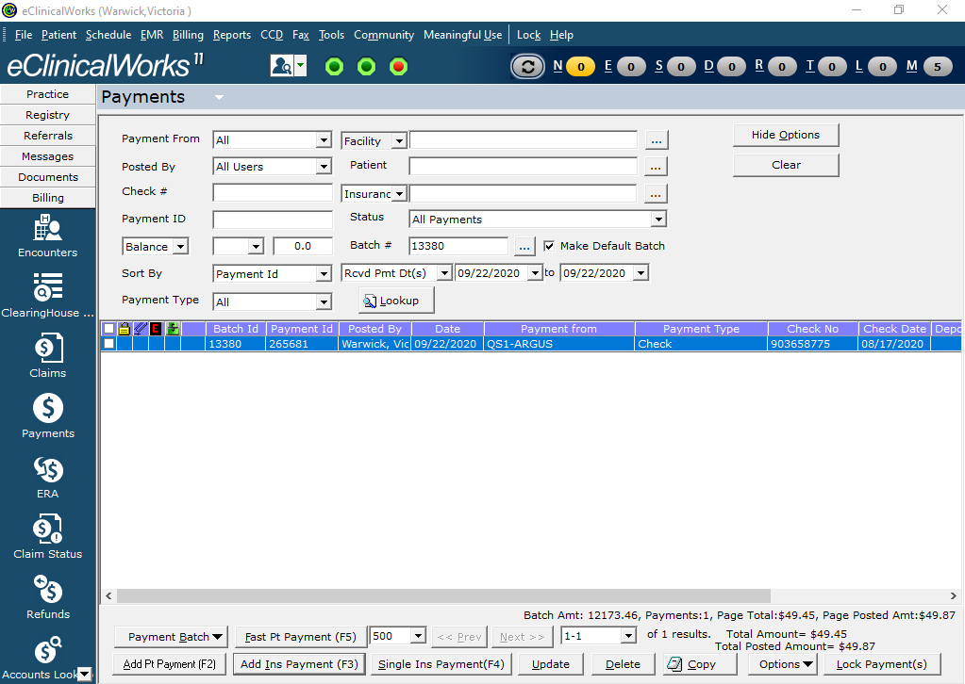

* In the Claims screen, click on the Claim dropdown



* Then select Create New Claim
* Search Patient PID that begins with 798…

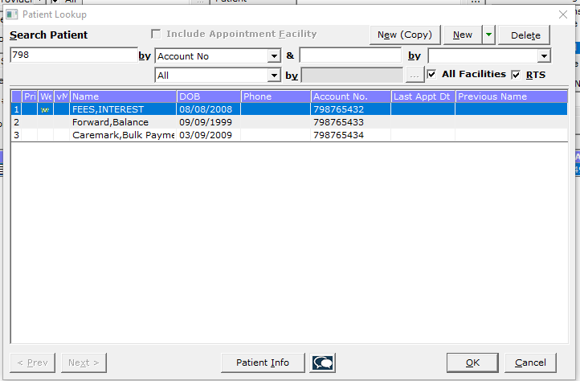

* You are given three choices:

FEES, INTEREST – these will be origination and/or transaction fees

Forward, Balance – usually just an Argus check will have this charge (+/-)

Caremark, Bulk Payment – Caremark pays us in bulk and we cannot identify specific patients

* After you select your “patient” – click OK
* The Create Claim screen comes up.

Provider: Dr. Thevy Chai

Resource: Dr. Thevy Chai

Facility: Admin Campus Health Services Admin

Service Date: will auto populate with today’s date

Patient: should be the patient you chose in the previous step

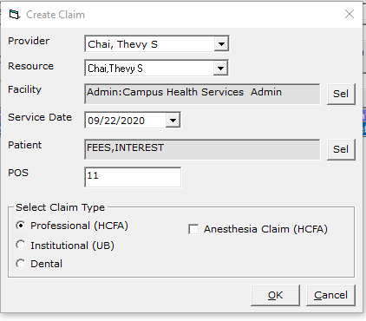

* Click OK
* Your claim screen will pop up.

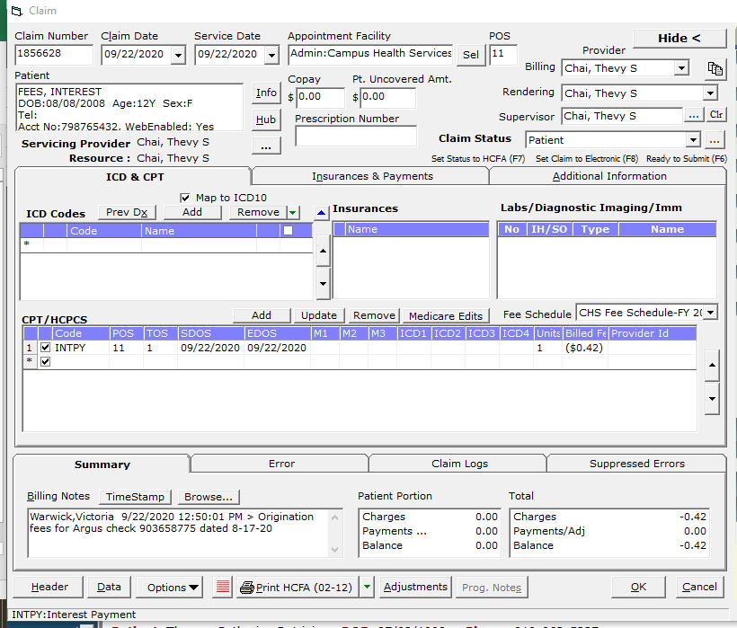

* Add CPT INTPY – When the Fee Schedule comes up, be sure to select the correct charge code for your interest payment:
  + 0 for Healthy Heels Shoppe (Campus Health Pharmacy) or
  + 1 for Student Stores Pharmacy.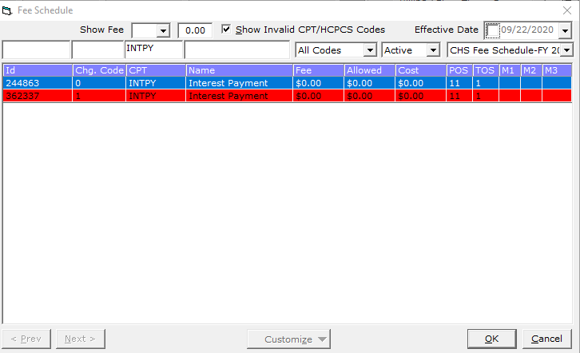
  + Click OK
* Add your interest charge, fee, refund, credit, etc under Billed Fee
* Add a billing note with your check number and date
* Make a note of the claim number
* Click OK

Go back to your Payments table

Double click on the Payment ID you are working on and click Payment Advisory to open your entries. In this example, our claim number was 1856628 and click GO

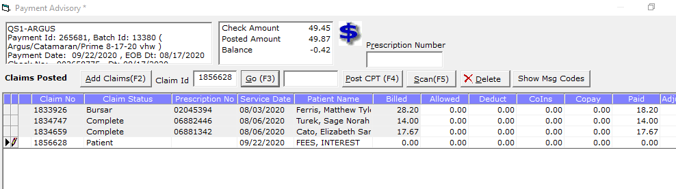

The claim you just created will pop up. Enter the adjustment and complete the claim and post it.

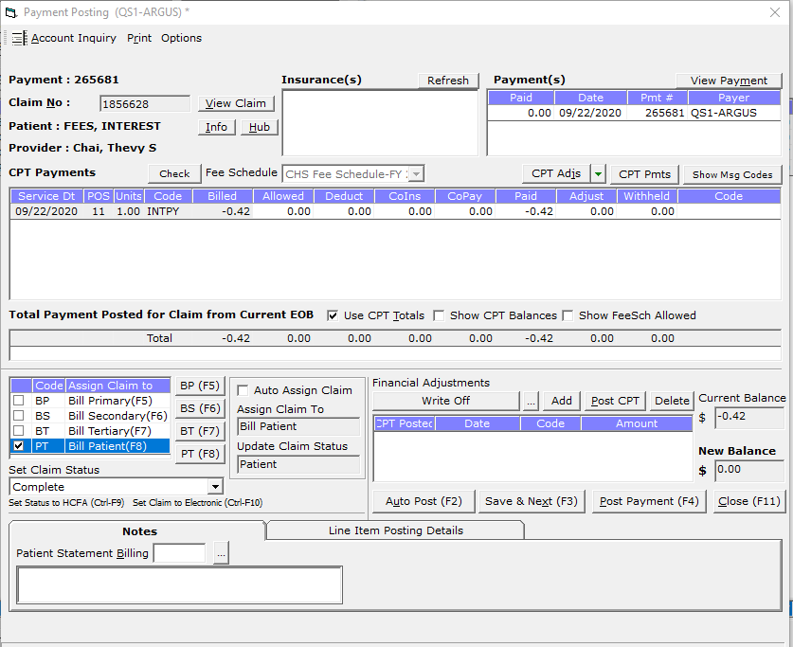

After you’ve entered all the credits, fees, interest, etc., your Payment Advisory should Balance to $0.00

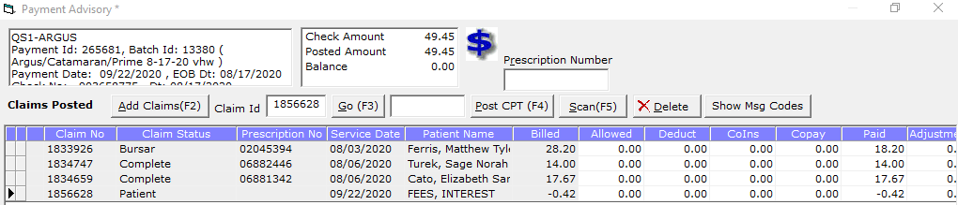

Click OK

Continue adding to this payment batch until you’ve posted all the vendors for this EOB.

Print your EBO Report and finish by Journaling the check and/or forwarding to accounting for processing.

Posting Pharmacy Checks Notes:

* DCT = Deposit ID
* If you need to set claim status to” Submitted RX Void”, then assign claim to “bill primary”
* For PRIME: 1+ and 1- with the same claim/service date, then don’t post it
* MedOne = TPS
* SS&C = Argus
* RX Advance = PRN RX Advantage